NAME: Dave Nearing CS466-001
CHAPTER: 2
LAB: 2

For each chapter, you will complete a set of Animated Flashcards, Book exercises, and Lab exercises. Although you will have three different activities, you will submit them in one document. Use this document to record your answers for submission.

ANIMATED FLASHCARDS

In order to receive any point value for the Book and Lab exercises, you must submit your answers to the chapter’s Animated Flashcards, found on the textbook companion web site. Identify your responses with the Flashcard question numbers in this section.

1. Binary digit
2. Bit
3. Base
4. Rational number
5. Byte
6. Number
7. Natural number
8. Positional notation
9. Negative number
10. Word
11. Integer
12.
13.
14.
BOOK EXERCISES

Refer to the chapter’s corresponding eLearning module or the course schedule for the assigned chapter exercises. Identify your responses to the exercises by including their numbers as they appear in the chapter in this section.

1. A
2. C
3. B
4. E
5. D
6. A
7. C
8. B
9. F
10. D

11. E
12. B
13. A
14. A
15. B
16. B
17. B
18.
19.
20.
21. a) 1
b) 3
c) 3
d) 7
e) 12

22. a) 8*10^2+9*10^1+1
b) 1*8^3+5*8^2+7*8^1+3
c) 6*12^2+2*12^1+3
d) 5*13^2+3*13^1+7
e) 3*16^2+7*16^1+12

23. a) 7
b) 511
c) 4076
d) 1911
e) 73

24. 8 is a power of 2

25.
26.
27.
28. a) 766
b) 101
c) 202
d) 142

29. a) A9
b) E7
c) 6E
d) 01121111 isn't a binary number.

30. a) 251
b) 347
c) 156
31. a) 1FF
b) 185
c) 123
d) 151
e) 1
32. a) 1605
b) 501
c) 2724
d) 2052
e) 3721

33. a) 101101
b) 1000101
c) 10000101010
d) 1100011
e) 1
34. a) 42A
b) 793
c) 1
d) 3E6
e) 2B

35. ♀♂♠♣♥♦♪♫
36. a) 354
b) ♪♫♦9
c) 1

37. a) 1655
b) 1010
c) 1071
38. a) 19AF9
b) AF8
c) BC33

39. a) 70
b) 247
c) 2222
40. a) 9AB
b) 98DD
c) 9566

41. Because computers calculate using transistors, which have 2 positions, on and off.
42. 8
43. 8
44. Pagers don't need anywhere near 64 bits to do what they need to do.
45. Because numbers exist in computers in fixed-size format.
46. 8
47. Uses 7 lights to represent the 10 digits.
LAB EXERCISES

The Lab Exercises are found on the textbook companion web site by clicking Explorations in Computer Science link, located in the left-side panel. Refer to the chapter’s corresponding eLearning module or the course schedule for the assigned exercises. Identify the Exercise and the activity’s number as you record your responses in this section.

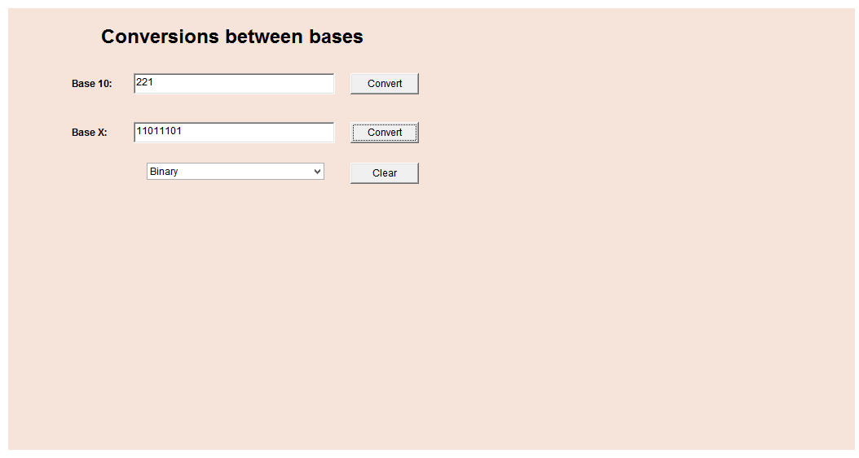
1. 1) 1*2^7+1*2^6+0*2^5+1*2^4+1*2^3+1*2^2+0*2^1+1 = 221
2)
3/4) 53/2=26r1
26/2=13r0
13/2=6r1
6/2=3r0
3/2=1r1
1/2=0r1
= 101011
5)

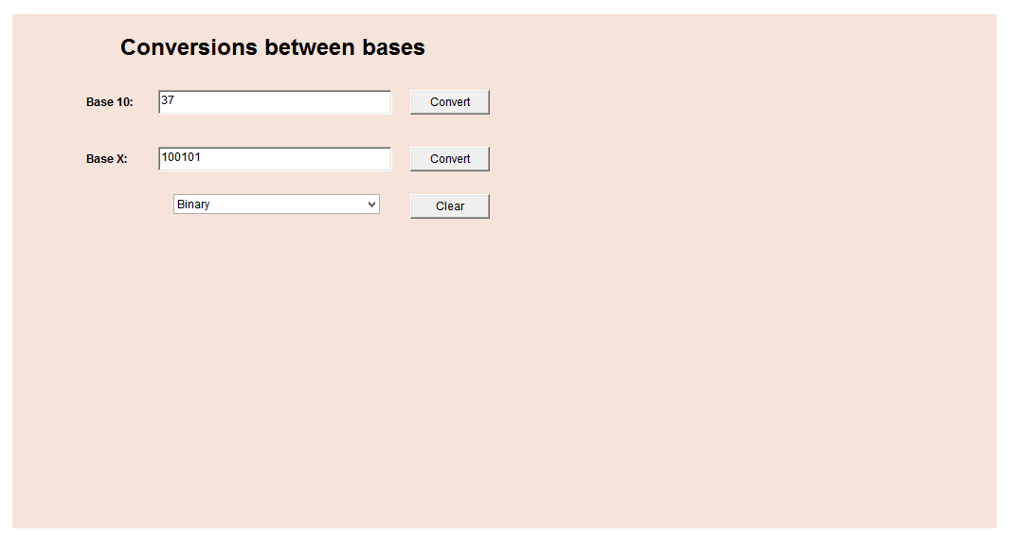

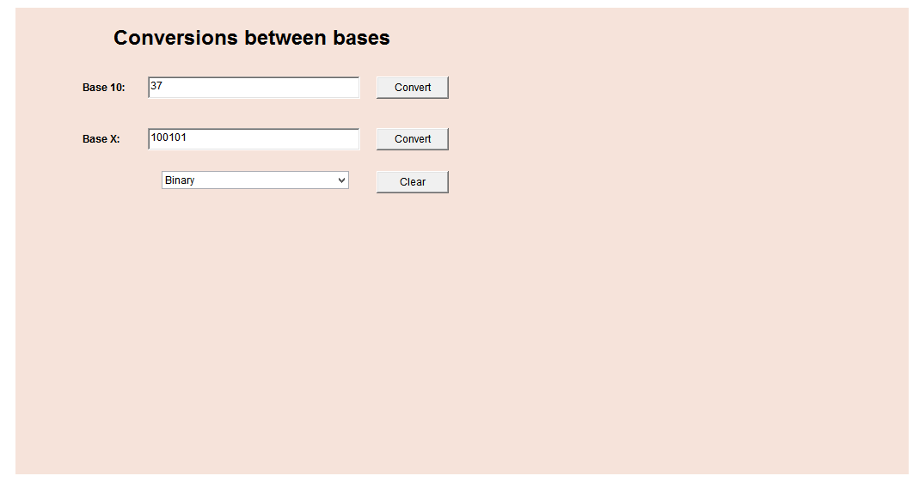
6) Because it multiplies the digits by the powers of the base.
7) Carries- 00111001
10101101
+ 00111001
11100110
8)
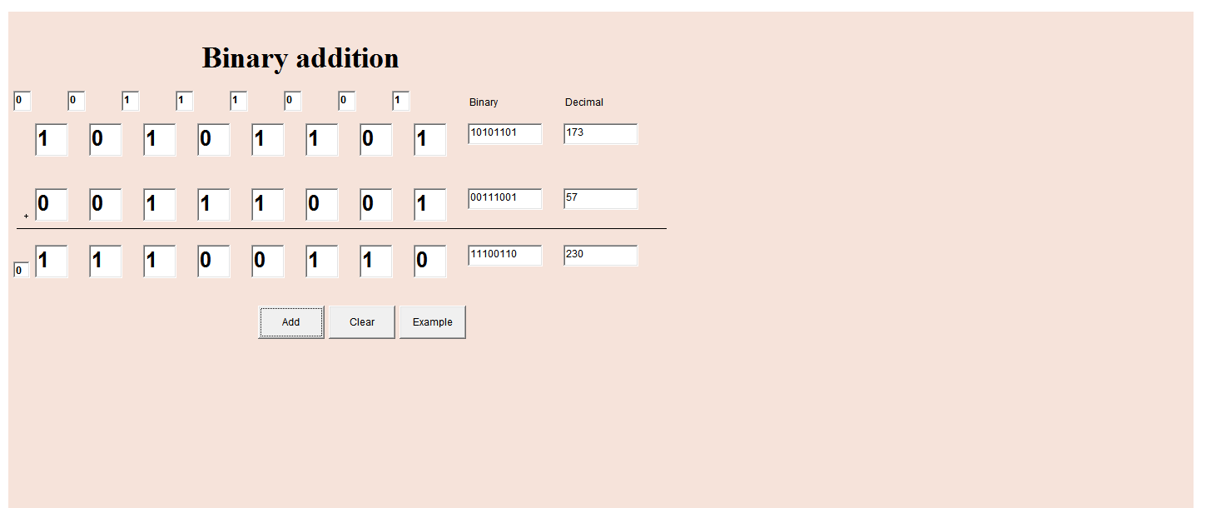

9) Largest- 11111111
Largest result- 111111110

